Miyazaki International College
Course Syllabus
FALL SEMESTER 2021/2022

Course Title ( Credits ) | ECO 306 Economics of Development (3 credits)
Course Designation for TC | N/A
Content Teacher
Instructor | PAWEL MLODKOWSKI
E-mail address | mpawel@sky.miyazaki-mic.ac.jp
Office/Ext | MIC 1-401/ telephone number (MIC-extension): 3727
Office hours | Tue 10:00 – 12:00, Thu 10:00 – 12:00
Language Teacher
Instructor
E-mail address
Office/Ext
Office hours

Course Description:
Much of the world’s population is affected by severe and persistent problems of under-production, unemployment, poverty, and numerous attendant hardships such as overpopulation, congestion, and ecological degradation. This course explores the forms and causes of these problems and the alternative theories for affecting economic development, using examples and cases to identify the constituent elements of development and the constraints facing development efforts.
Students examine theories and issues, internal and external challenges, and alternative policy options relating to sustainable economic development. Topics include a comparative analysis of the leading theories of economic growth, development, and sustainability; lack of economic growth, poverty, and income distribution; consequences of population growth and technological change; employment and migration, human capital, agriculture, and rural development; international trade and commercial policy, foreign investment, and aid; and global integration, economic transition, and environmental degradation.
Course Objectives:
After completing this course, students should be able to:
- Describe appropriate measures or indicators of development.
- Explain economic growth and development theories, and their implications on sustainable development.
- Identify the conditions of underdevelopment and the challenges for sustainability.
- Discuss poverty, income distribution, and the causes and consequences of population growth.
- Summarize the process of sustainable economic development.
- Critique the significance of employment, migration, human capital development, rural development, international trade, and foreign aid and investment on sustainable economic development.
- Appraise economic transition and environmental degradation.
Relate the effect of globalization on sustainable economic development.
Teaching Methodology:
Course objectives will be achieved through a variety of active learning teaching strategies, including but not limited to:
Active Learning Teaching Strategy | Course Schedule
Pair and group work | Most classes
Self-assessment and peer review | Most classes
Interactive lectures with note taking | Most classes

Course Schedule
Day | Topic | Content/Activities
1 | UNIT ONE: Introduction to the class goals | Introduction of the teachers  Presentation of the syllabus  Explanation of the terms of engagement  Presentation of the teacher’s expectations  Reading assignment for the next session  An introduction to the study of economic development  Handout 1: Economic Development basic concepts
2 | UNIT TWO: Issues of Definition and Measurement | Introduction to the nature and scope of development economics
3 |  | Use of appropriate measures for development
4 |  | The structure of Third World economies
5 |  | Common characteristics of developing nations
6 |  | Assessment 1: group presentations on – 10%.
7 | UNIT THREE: Historical Perspective on Growth & Theories of Development | A comparative analysis of the leading theories of economic development
8 |  | The linear-stages models
9 |  | The structural-change models
10 |  | The international-dependence models
11 |  | The neoclassical models
12 |  | The new growth models
13 | UNIT FOUR: The Conditions of Underdevelopment and Challenges for Sustainability | An examination of the conditions of underdevelopment
14
15 |  | Lack of economic growth
16
17 |  | Poverty and income distribution
18
19 |  | Causes and consequences of population growth
20 | UNIT FIVE: The Process of Sustainable Economic Development | An examination of internal and external dimensions of economic development
21 |  | Employment and migration and Human capital
22 |  | Agriculture
23 |  | Rural development
24 |  | International trade and commercial policy
25 |  | Foreign investment and aid
26 |  | Foreign investment and aid
27 | UNIT SIX: Integration: Globalization, the Environment and Sustainable Development | An examination of the challenges faced by developing economies
28 |  | The ongoing process of global integration
29 |  | Economic transition and environmental degradation
30 | Revision | Economic development models and theories
 | Final Exam | Final Report
Required Materials:
Todaro, Michael P. and Stephen C. Smith, Economic Development, 11th Edition, Pearson, 2012.
Course Policies (Attendance, etc.)
Participation is required at all classes. Students are expected to attend all the classes on time, participate actively in all class activities and complete all assignments on time. As criteria to pass this course, students are required to attend at least 66% of the total class time. If you have more 'unexcused absences' you will be asked to withdraw from the class. All kind of absences must be presented with concrete documents and will be approved case by case. Problems related to your class performance should be brought up to the instructor as soon as possible.
An 'unexcused absence' is any absence for which you do not have permission. Medical reasons, family emergencies and so on are NOT counted as "unexcused absences" and will NOT INFLUENCE YOUR GRADE.
Class Preparation and Review
Students are expected to spend at least one hour preparing for every hour of lesson, and one hour reviewing and doing Homework. The reading materials must be read and prepared before class. Lectures will stress the most important issues addressed in the materials, and may go beyond the scope of the handouts for certain topics. Therefore, it is important for you to attend class.
Grades and Grading Standards
Presentation: 10%
2 x Quiz: multiple-choice questions: 2 x 10% = 20%
Mid-term report: 20%
Participation: 10%
Final report: 40%
Attendance as such is not part of the final grade – BUT participation is! Participation means asking questions, answering questions, and demonstrating the willingness to try to work at a serious level.
Methods of Feedback:
Students receive feedback in two forms.
Feedback on their performance in the classroom is provided in the real time.
Feedback on students’ oral answers is provided ad hoc in the classroom during classroom activities
Feedback on written work is provided within one week from the submission.
Diploma Policy Objectives:
Work completed in this course helps students achieve the following Diploma Policy objective(s):
1: Advanced thinking skills (comparison, analysis, synthesis, and evaluation) based on critical thinking (critical and analytic thought)
2: The ability to understand and accept different cultures developed through acquisition of a broad knowledge and comparison of the cultures of Japan and other nations
3: The ability to identify and solve problems
4: Advanced communicative proficiency in English
5: Proficiency in the use of information technology
Notes:
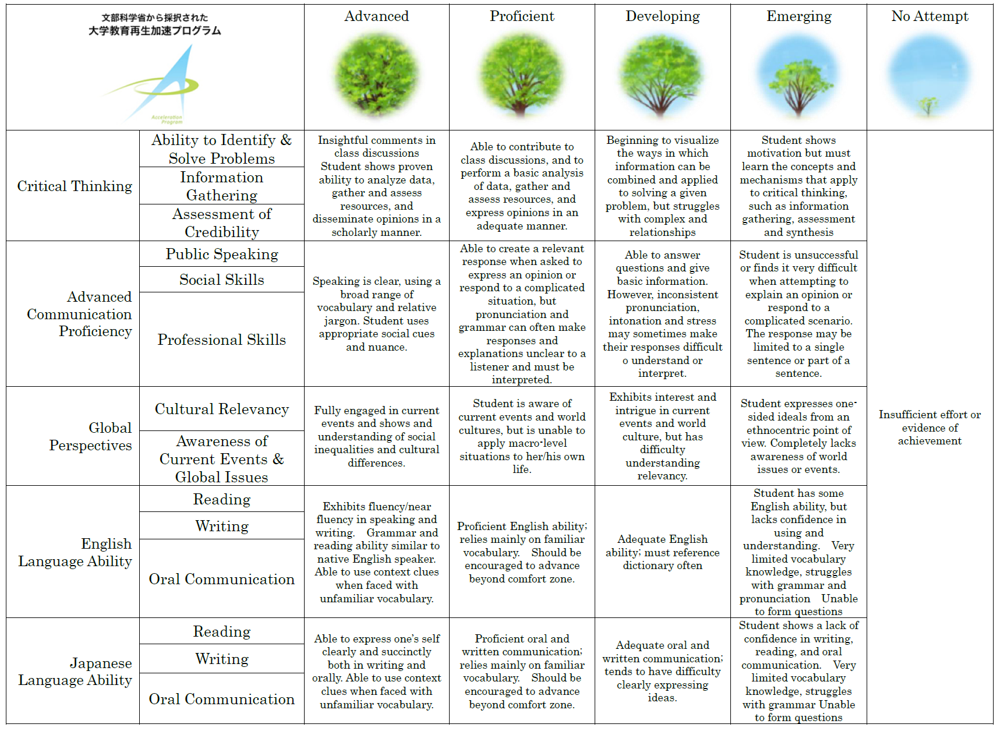

 |  | Advanced | Proficient | Developing | Emerging | No Attempt
Critical Thinking | Ability to Identify & Solve Problems | Insightful comments in class discussions  Student shows proven ability to analyze data, gather and assess resources, and disseminate opinions in a scholarly manner. | Able to contribute to class discussions, and to perform a basic analysis of data, gather and assess resources, and express opinions in an adequate manner. | Beginning to visualize the ways in which information can be combined and applied to solving a given problem, but struggles with complex and relationships | Student shows motivation but must learn the concepts and mechanisms that apply to critical thinking, such as information gathering, assessment and synthesis | I had no idea that this student was even enrolled in my class that is how underwhelming this student’s performance was!
 | Information Gathering
 | Assessment of Credibility
Advanced Communication Proficiency | Public Speaking | Speaking is clear, using a broad range of vocabulary and relative jargon. Student uses appropriate social cues and nuance. | Able to create a relevant response when asked to express an opinion or respond to a complicated  situation, but pronunciation and grammar can often make responses and explanations unclear to a listener and must be interpreted. | Able to answer questions and give basic information. However, inconsistent pronunciation, intonation and stress may sometimes make their responses difficult  to understand or interpret. | Student is unsuccessful or finds it very difficult when attempting to explain an opinion or respond to a complicated scenario. The response may be limited to a single sentence or part of a sentence.
 | Social Skills
 | Professional Skills
Global Perspectives | Cultural Relevancy | Fully engaged in current events and shows and understanding of social inequalities and cultural differences. | Student is aware of current events and world cultures, but is unable to apply macro-level situations to her/his own life. | Exhibits interest and intrigue in current events and world culture, but has difficulty understanding relevancy. | Student expresses one-sided ideals from an ethnocentric point of view. Completely lacks awareness of world issues or events.
 | Awareness of Current Events & Global Issues
English Language Ability | Reading | Exhibits fluency/near fluency in speaking and writing. Grammar and reading ability similar to native English speaker. Able to use context clues when faced with unfamiliar vocabulary. | Proficient English ability; relies mainly on familiar vocabulary. Should be encouraged to advanced beyond comfort zone. | Adequate English ability; must reference dictionary often | Student has some English ability, but lacks confidence in using and understanding. Very limited vocabulary knowledge, struggles with grammar and pronunciation Unable to form questions
 | Writing
 | Oral Communication
Japanese Language Ability | Reading | Able to express one’s self clearly and succinctly both in writing and orally. Able to use context clues when faced with unfamiliar vocabulary. | Proficient oral and written communication; relies mainly on familiar vocabulary. Should be encouraged to advanced beyond comfort zone. | Adequate oral and written communication; tends to have difficulty clearly expressing ideas. | Student shows a lack of confidence in writing, reading, and oral communication. Very limited vocabulary knowledge, struggles with grammar Unable to form questions
 | Writing
 | Oral Communication

